Modern Home Gardening Project
Chapter 1: Introduction
Most of people have shifted to vegetation, so they need the way to get fresh vegetable in their dinning table. But most of vegetable is bought from the market that question the freshness of the vegetable. Freshness of vegetable is highly related to our health and nutrition. In order to get fresh vegetable, home gardening should be started. However, most of people doesn’t have time and courage to garden. But this problem can be solved by autonomous garden. This project deal with autonomous gardening with little range: watering and illuminating at low light or dark time. But autonomous gardening includes herb and pest control; soil fertilizing; collect the fruit, the leaf or the root when it is mature.
Chapter 2: Method
This project deal only with watering and illuminating the plant at night or low light intensity season. The project has two part the first part is watering and the second part is illuminating. These two parts is controlled using micro controller.
- Watering Sub-system:
In order to water the plant, the moisture of the soil must be checked. The soil moisture is checked by the sensor called soil moisture sensor. This soil moisture sensor changes its resistance or capacitance when the moisture of the soil changes. So, the change in its resistance or capacitance change into voltage signal to be processed by micro controller board.
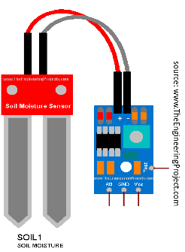figure 1: Soil moisture that use resistivity
The micro controller board check the soil moisture level in order to water the plant. If the soil moisture is below given level, it turns on the servo motor to open the valve so that the plant be watered. To close the water, valve the soil moisture is checked. If the soil moisture is greater than the given level it turns it off.
- Illuminating Sub-system:
In some area of the world, there is a season which is too low light intensity to produce efficient garden product. Moreover, in some home garden is full of shadow to reduce the product of garden. The other reason to use this subsystem is to get more product by illuminating the garden at night.
The characteristics of the plant can be influenced by wave length of the light emitted. So, using this subsystem it can be controlled to give desired wave length of light using RGB LED. The following table give brief effect of some light wavelength on a plant.
Wave length of light | Effect on the plant
Blue light (400-500 nm) | is crucial for photosynthesis. It has the highest energy and promotes plant growth. And it affects the leaf part of the plant.
Red light (600-700 nm) | also plays a significant role. It stimulates flowering and fruit production
Green light (500-600 nm) | is less effective for photosynthesis but helps protect plants from damage
This subsystem is controlled by light intensity sensor. The light intensity of the environment is detected using light dependent resistance (LDR) that changes it resistance with the light intensity of the environment. When constant voltage is applied to the LDR, then it yields voltage signal. Therefore, the voltage signal is processed by micro controller to switch the intensity of the system. The total project system looks like as a figure 2.
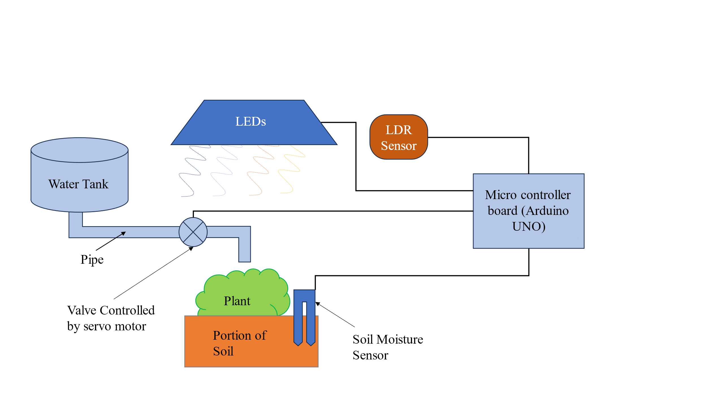
Figure 2: limited range autonomous gardening system
- Micro controller:
In this project Arduino UNO is used in order to control the whole system. The Arduino is programmed in order to control in desired way. The figure of Arduino Uno is given in figure 3.
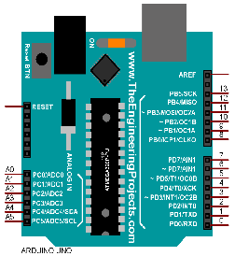Figure 3: Arduino UNO
Chapter 3: Circuit and Code
When the above-described system is implemented to circuit it become as in figure 4. The circuit diagram has two sensors soil moisture sensor and LDR for the water content of the soil and the light intensity of the environment. Moreover, the circuit has two actuator the LED and the Servo motor that respond to the change of light intensity and soil moisture. At the end it has 3 resistors to limit the current through the resistor and 2 variable resistors one for test signal of soil moisture and controlling LDR.
The code part is to make the micro controller to do what we have desired
#include <Servo.h> // servo library to run servo
Servo servo; // servo is our Servo [making object servo]

int LDR = A5; // LDR pin in Ardiuno UNO
int Soil = A0; // Soil_moisture sensor pin in Ardiuno UNO
int Servopin = 7; // Servo pin in Ardiuno UNO
int LED = 5; // LED pin in Ardiuno UNO
int motor = 1; // the servo motor position i 1 for 180 degree and 2 for 0

void setup() {
servo.attach(Servopin); //where servo motor position is
pinMode(LED,OUTPUT);} //where LED pin is and to show it is output voltage source

void loop() {
int Soilmoisture = analogRead(Soil); // the amount of voltage source is read and convert to the range [0,1023]
if (Soilmoisture < 500 && motor == 1){ // if soil moisture is less and the motor valve is closed
servo.write(0); //turn on servo motor on (rotate the servo motor to 0 degree)
delay(30); //delay 30 mili second
motor = 2; } // the water valve is on
if (Soilmoisture >= 600 && motor == 2){ //if soil moisture is more and the motor valve is opened
servo.write(180);
delay(30);
motor=1;}

int Light_intensity = analogRead(LDR); // read the analog voltage from the LDR
int Light_value = map(Light_intensity, 205, 1023, 0, 255); // to map the value from [205, 1023] to [0, 255]

if (Light_value < 120){ // if the light value is less then 120 turn of the LED off
digitalWrite(LED, LOW);
}else{
digitalWrite(LED, Light_value);// else make the value to Light value. {you can use the value from 0 to 255} }}
Chapter 4: Result and Discussion
The simulation part work properly as a desired that make the water valve to open (-90⁰) to close (90⁰). And to illuminate the light below desired light intensity level.
Chapter 5: Limitation and Hope of the project
This project is mainly focus on basic things for plant growth. But it is not enough it must add camera sensors to control herb and pest, and attack it through laser or pesticide or herbicide. Also, it must include the sensor that check soil nutrient content or plant growth stage so that it adds soil fertilizers. The other think it checks the ripeness of the plant in order to announce it or to collect it into the basket.
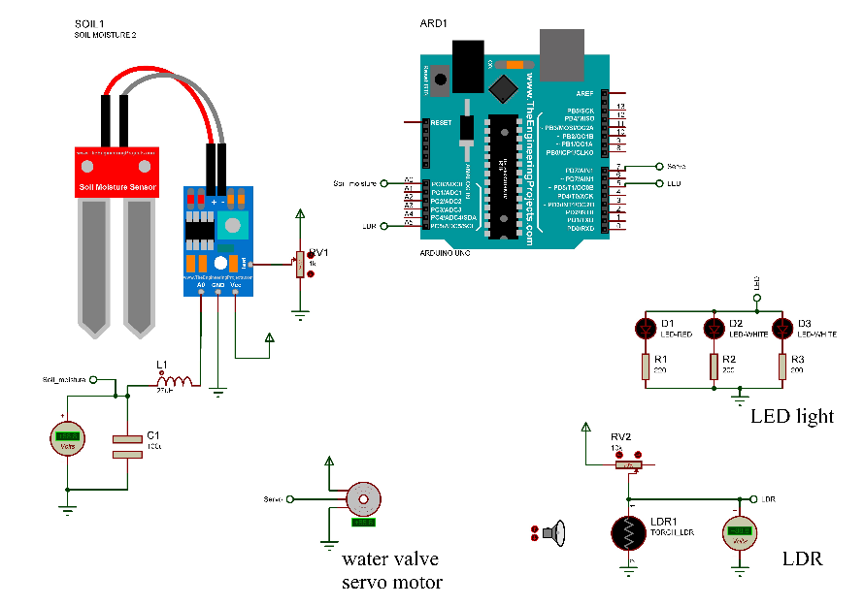Figure 4: the circuit diagram

